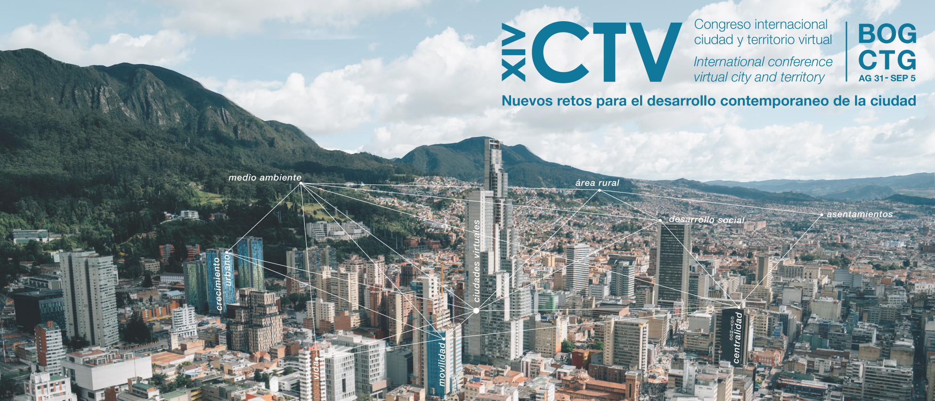

TITLE: USING ARIAL FONT SIZE 12 AND BOLD

Key words: word 1; word 2; word 3; word 4 (minimum three and maximum four)

Thematic line*: Indicate one (1) between the ten (10) tables of the Conference.

Abstract

Authors, must not be indicated here. All must be indicated in OJS, following next indications; Names, Surnames, Email, ORCID ID, URL (if available), Institution, Country, Biographical Summary (short). In addition, the contact author for correspondence must be indicated.

The abstract must contain; clarify objectives of the communication, methodology, data used, development, results and main conclusions. Remember that the extension must be between 250 and 300 words.

